# A4 BUG2 REPORT

# Name: Ty Saunders

# Student ID: 11748199

# Assignment details: Debugging task

# Bug 2: Loan limit being enforced incorrectly

When a Patron borrows items, the loan limit is supposed to be enforced after 2 items, but instead it is being enforced after 3 items. When a Patron returns later, they can borrow yet another item before the loan limit is enforced again. They can do this over and over until the library runs out of books.

Contents – Click links to jump to section:

1. Demonstration
2. Replication
3. Simplification
4. Tracing
5. Resolution
6. Validation

1. Demonstration:

|  |  |
| --- | --- |
| Issue 1:  When a patron with 0 loans borrows multiple items:  Loan limit should be triggered after 2 items  But it is not triggered until after 3 items |  |

|  |  |
| --- | --- |
| Issue 2:  When a patron who has exceeded the loan limit returns later to try to borrow items again  It is incorrectly allowing them to borrow 1 more item before enforcing the limit. |  |

2. Replication

**System Test:**

The steps to manually replicate the error are contained in a separate document in the same directory as this document: Bug2SystemTest.pdf.

Here is a link to the document on github for quick reference: [Bug2SystemTest.pdf](https://github.com/tysau/A4debugging/blob/main/BugReports/Bug2SystemTest.pdf)

In summary the steps are to begin with a patron who has no loans, then attempt to borrow items until stopped. For issue 2, the steps are to return later and try to borrow more items.

3. Simplification

This section uses Hypothesis / Test / Result process to narrow down the cause to the point where a simplified automated test can be written to reproduce it easily.

* H1 – BorrowItemControl is not correctly enforcing the loan limit
* T1 – Visually inspect BorrowItemControl to understand how the borrow process works
* R1 – UI sets control state to READY, control sets UI’s state to READY, control.CardSwiped is called, which contains a line of code which calls library.canPatronBorrow method which is called once at the beginning of the borrow session. This method in Library needs to be checked. There is another method (itemScanned) which is also deciding if patron can continue to borrow after each item is added.

**Result:** Automated test can be done from BorrowItemControl class.

**Automated Test:**

Test case has been written to replicate this bug quickly. It can be run by opening the project, found in this directory: A4\src\test\java\library.Bug2Test.java

The test can be run by opening the project, right-click Bug2Test.java and click “Test”.

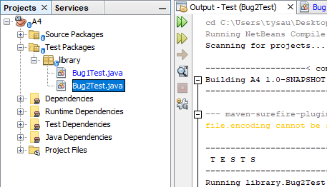

**Screenshots of the test code:**

# **Script set up:**

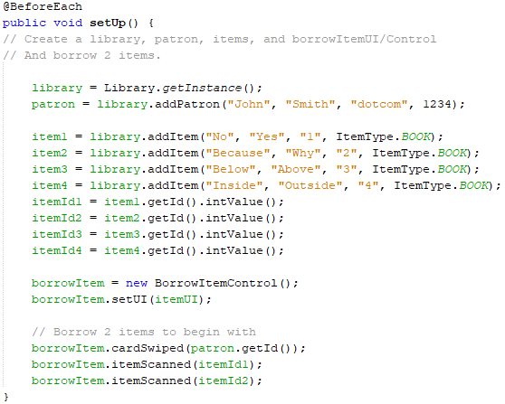

**Script 2.1**

# 

**Script 2.2**

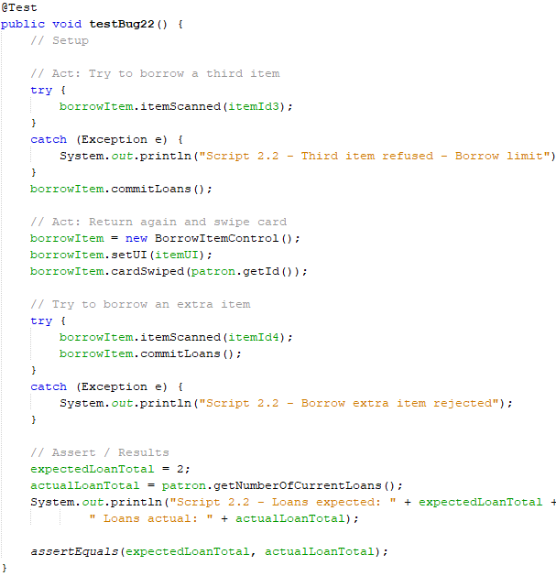

**Screenshot of the test being run and failing as expected before the fix:**

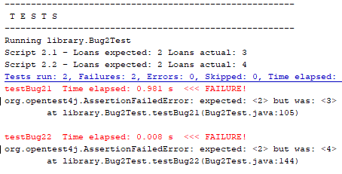

**Version control: Screenshot of commit for the test code:**

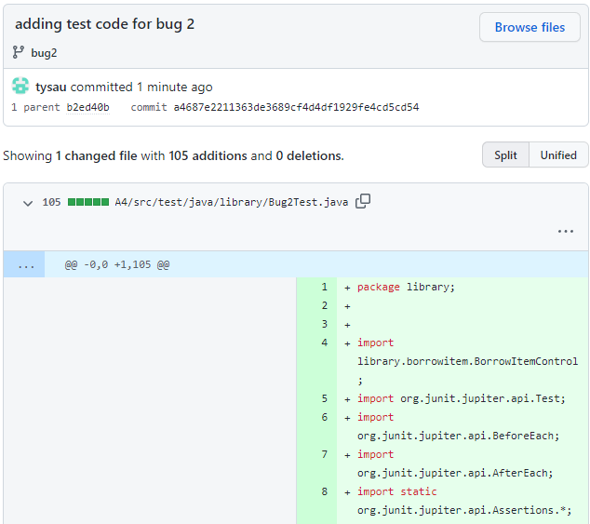

Bug 2 Tracing:

In ReturnItemControl method CardSwiped is called, which contains a line of code which calls library.canPatronBorrow method. This method in Library needs to be checked.

* H1 – Library.canPatronBorrow is not correctly determining if patron can borrow.
* T1 – Run the test with break points before and after canPatronBorrow.
* R1 – True – canPatronBorrow is only stopping the patron from taking a loan if they have exactly 2 loans. If the patron somehow has 3 or more, they can continue to borrow. This is not the root cause because some other validation is responsible for letting the patron get above 3 loans, but it could be changed to >=2 for extra robustness.

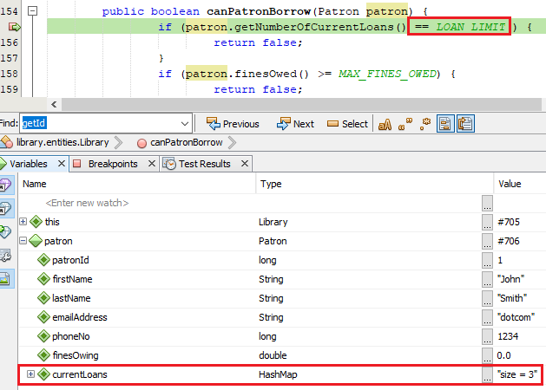

* H2 – BorrowItemControl itemScanned method is not correctly enforcing the loan limit
* T2 – Visually inspect itemScanned method to understand how it works
* R2 – See that line 79 is checking the result of a method in library: getNumberOfLoansRemainingForPatron minus the pending Item List and deciding to enforce the item limit based on that. Need to inspect: getNumberOfLoansRemainingForPatron.
* H3 – getNumberOfLoansRemainingForPatron could be returning incorrect limit
* T3 – Visually inspect what getNumberOfLoansRemainingForPatron is doing
* R3 – FALSE: The method is taking the LOAN_LIMIT which is a constant 2 and subtracting the current loans the patron has. In this case we have a new patron borrowing for the first time who will have 0 loans to this method will be returning 2. This method is returning correctly.

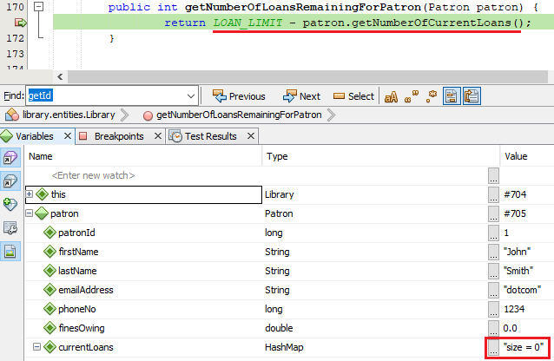

* H4 – BorrowItemControl itemScanned method is using incorrect logic to determine if patron can borrow.
* T4 – Visually inspect itemScanned again to check the logic.
* R4 – True - We can see that the line of code to determine if a patron can borrow is getting amount of loans remaining and subtracting the pending list size, if this results in less than zero, the loan limit will be enforced. Less than zero means the patron can have minus 1 loans remaining before being stopped.

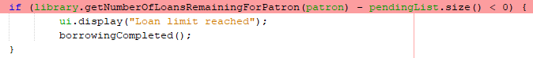

In the case of this bug the values passed to getNumberOfLoansRemaining are:

|  |  |
| --- | --- |
| Library.getNumberOfLoansRemainingForPatron | **2** |
| pendingList.size() | **2** |
| Library.getNumberOfLoansRemainingForPatron   * pendingList.size() | **0** |

0 is not less than 0.

Therefore the code below it to enforce the loan limit will not be executed and the patron can borrow another item.

Conclusion of bug tracing:

**The root cause –**

Maths to calculate if a patron can continue to borrow additional items is wrong in BorrowItemControl.itemScanned() method.



**Secondary contributor –**

If patron somehow manages to exceed 2 loans, they can borrow infinitely after this on separate visits, due to the logic in Library.canPatronBorrow method.

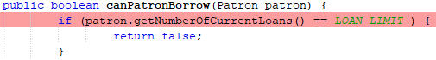

Resolution:

**Fix:** Update the code in BorrowItemControl line 79 and Library line 156 to rectify the issues above.

Fix Plan:

* Use a separate code branch other than main.
* Apply Fix 1, run test to confirm bug 2.2 (returning later to borrow more) is resolved.
* Apply Fix 2, run test to confirm both bug 2.1 (borrowing more than 2 items) and 2.2 are passing.
* Run regression test for bug 1 to confirm it is still fixed.

**FIX 1: Library:**

Change line 156 to correct the loan limit calculation logic by changing:

== 0

To:

>= 0

Then run test case 2.2 to confirm patron is unable to borrow a 4th item on a later visit.

**FIX 2: BorrowItemControl:**

Change line 79 to correct the loan limit calculation logic in line 79 by changing:

< 0

To:

<= 0

Then run test case 2.1 to confirm patron is unable to borrow an extra item in their first borrowing session.

Validation:

**Fix 1 result (borrowing more in later visit):**

**Code before:**

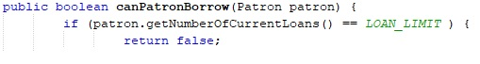

**Code after:**

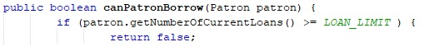

**Test results before – 4 items borrowed:**



**Test results after – 3 items borrowed:**



**User test results after fix:**

Patron is denied from borrowing later if they have exceeded the loan limit



**Result: FIXED - Borrowing extra items on later visits is resolved**

**Fix 2 result (Borrowing more than 2 items)**

**Code before:**

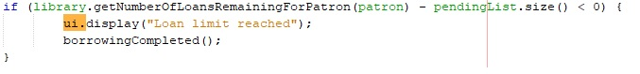

**Code after:**

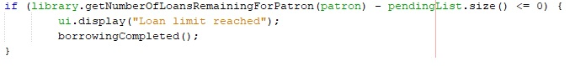

**Test results before fix:**



**Test results after fix – the test case is now passing:**



**User test results after fix:**

**Patron can borrow only 2 items – PASS.**

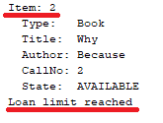

**Result: FIXED - Borrowing more than item limit in a single visit is resolved.**

**Run all tests for Bug 2:**

**Both tests are passing:**

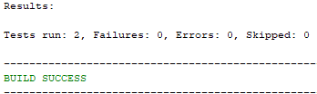

**Regression test – confirm Bug 1 is still fixed:**

**Bug 1 is still passing:**

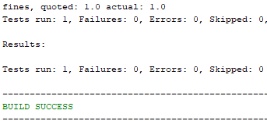

**Fix deployed, committed to remote repo - GitHub commit screenshot:**

